[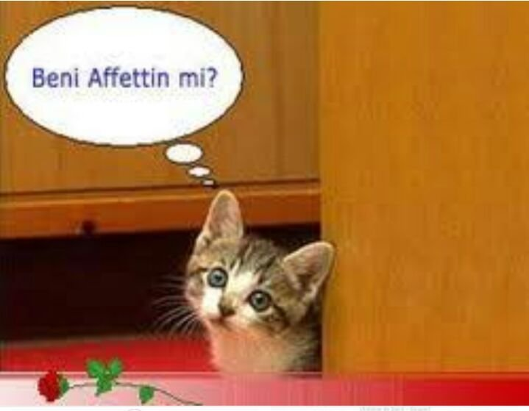](https://www.artibasari.com.tr/dokuman/3/2997)

[Beni affettin mi?](https://www.artibasari.com.tr/dokuman/3/2997)

[](https://www.artibasari.com.tr/dokuman/3/2996)

[Lütfen Affet](https://www.artibasari.com.tr/dokuman/3/2996)

[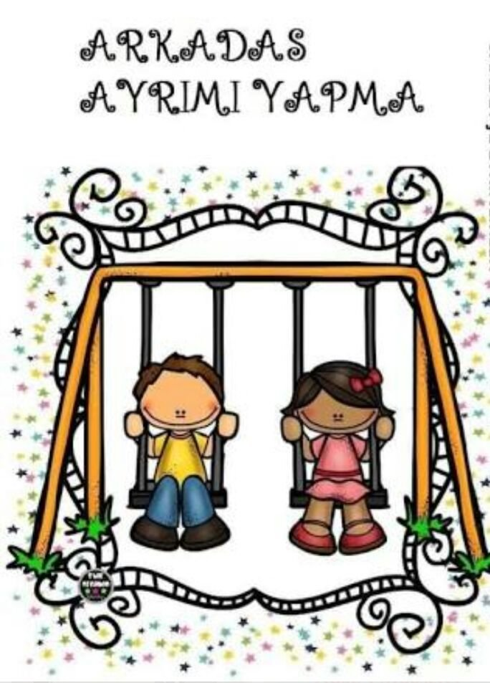](https://www.artibasari.com.tr/dokuman/3/2995)

[Arkadaş ayrımı yapma](https://www.artibasari.com.tr/dokuman/3/2995)

[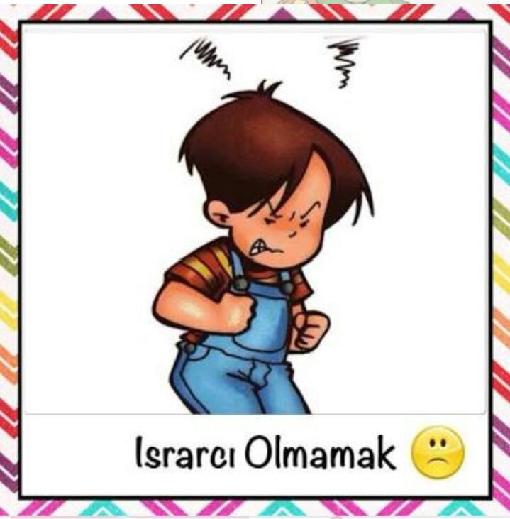](https://www.artibasari.com.tr/dokuman/3/2994)

[Israrcı olmamak](https://www.artibasari.com.tr/dokuman/3/2994)

[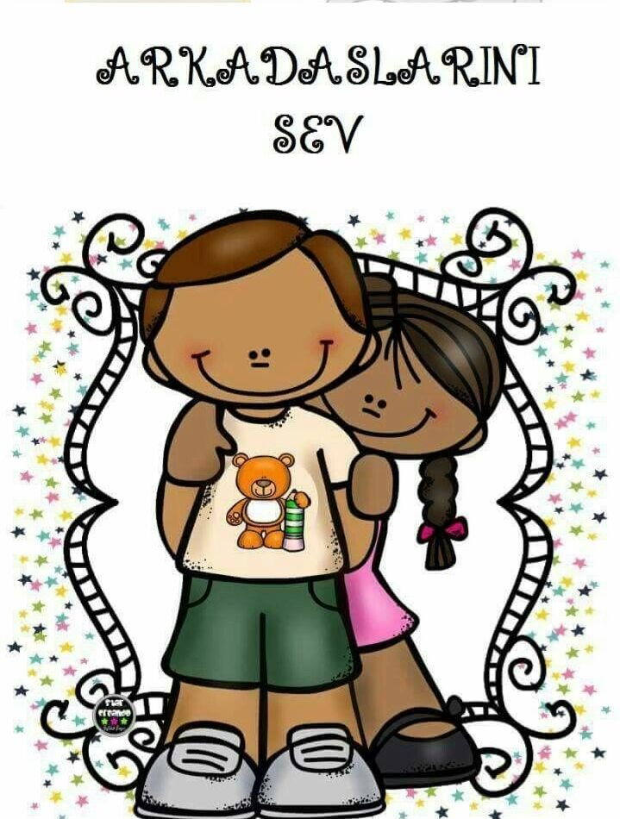](https://www.artibasari.com.tr/dokuman/3/2993)

[Arkadaşlarını sev](https://www.artibasari.com.tr/dokuman/3/2993)

[](https://www.artibasari.com.tr/dokuman/3/2992)

[Saygılı ol](https://www.artibasari.com.tr/dokuman/3/2992)

[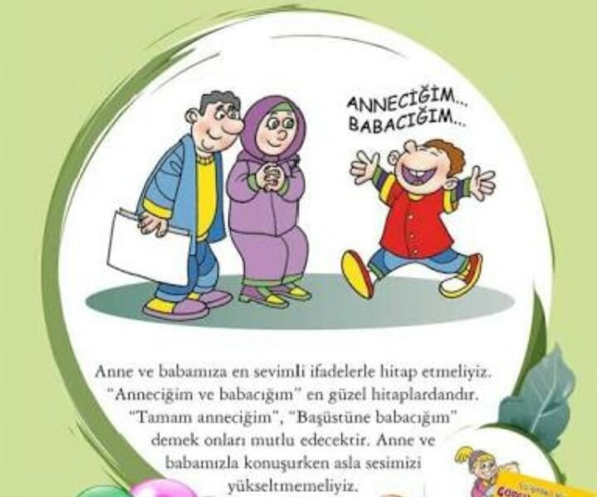](https://www.artibasari.com.tr/dokuman/3/2991)

[Anne babaya hitap](https://www.artibasari.com.tr/dokuman/3/2991)

[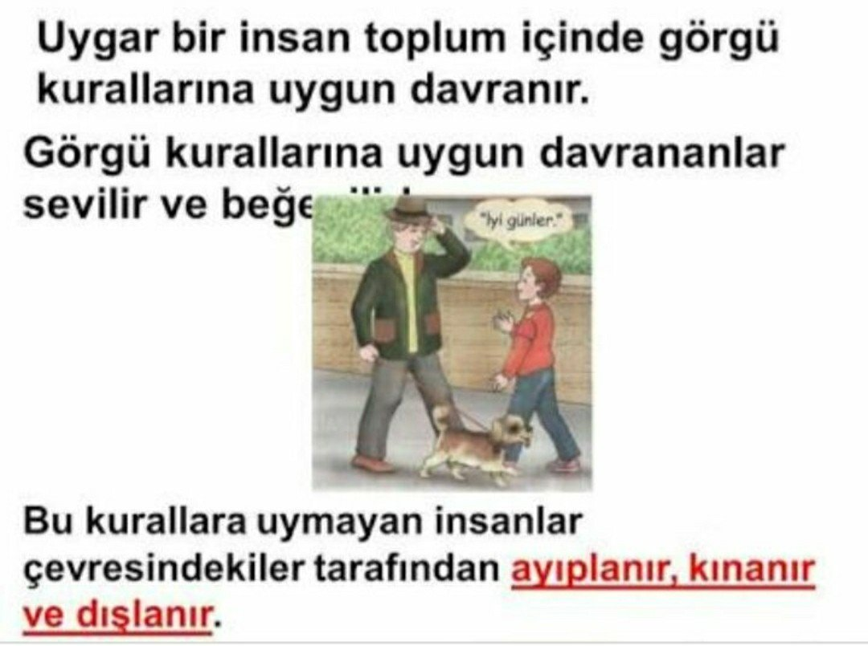](https://www.artibasari.com.tr/dokuman/3/2657)

[İyi Günler](https://www.artibasari.com.tr/dokuman/3/2657)

[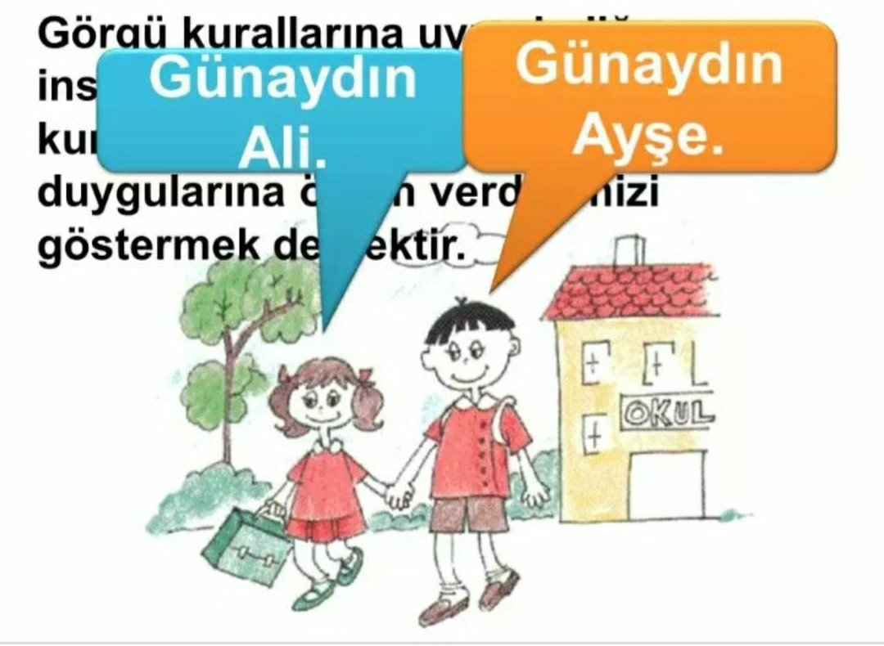](https://www.artibasari.com.tr/dokuman/3/2656)

[Günaydın](https://www.artibasari.com.tr/dokuman/3/2656)

[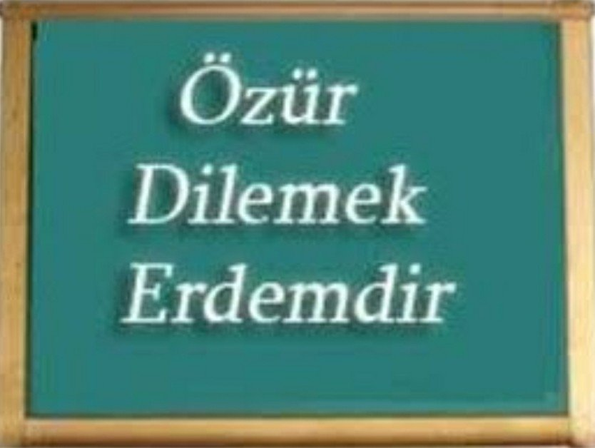](https://www.artibasari.com.tr/dokuman/3/2655)

[Özür Dilemek](https://www.artibasari.com.tr/dokuman/3/2655)

[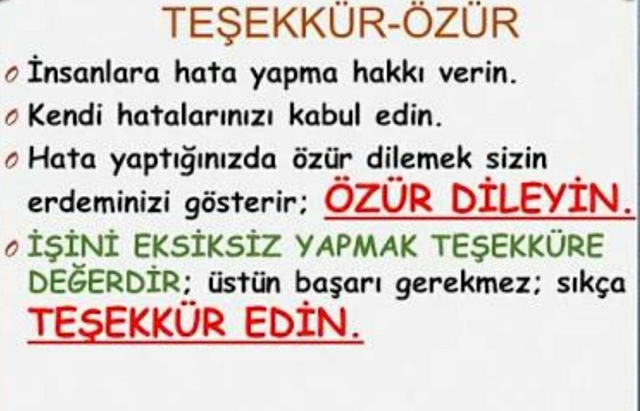](https://www.artibasari.com.tr/dokuman/3/2654)

[Teşekkür-Özür](https://www.artibasari.com.tr/dokuman/3/2654)

[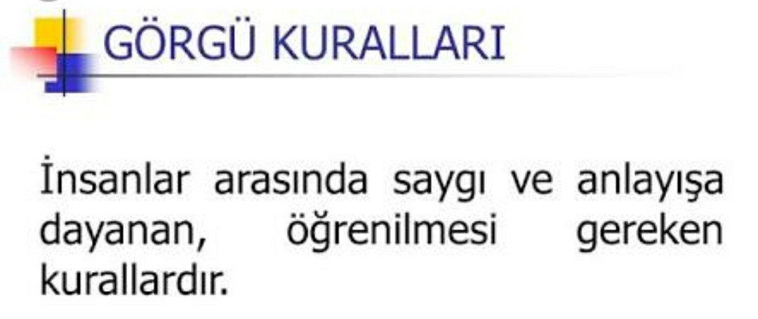](https://www.artibasari.com.tr/dokuman/3/2653)

[Görgü kuralları](https://www.artibasari.com.tr/dokuman/3/2653)

[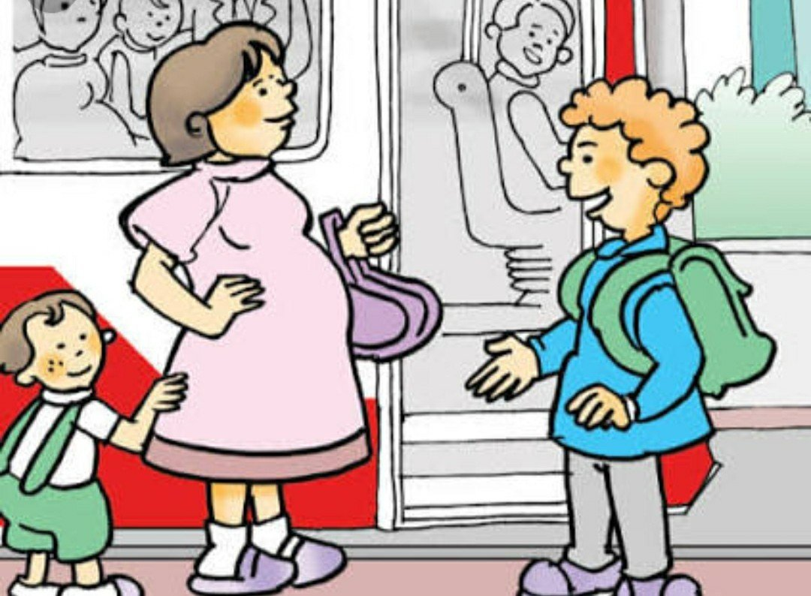](https://www.artibasari.com.tr/dokuman/3/2652)

[Hamilelere öncelik verelim](https://www.artibasari.com.tr/dokuman/3/2652)

[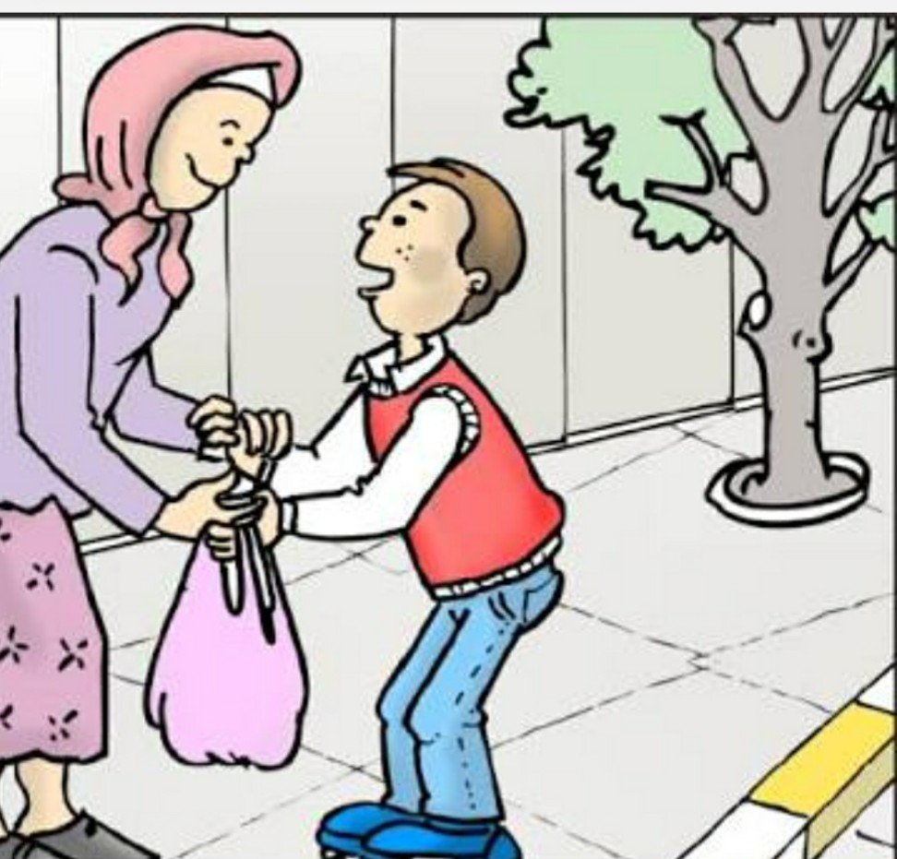](https://www.artibasari.com.tr/dokuman/3/2651)

[Yardım et](https://www.artibasari.com.tr/dokuman/3/2651)

[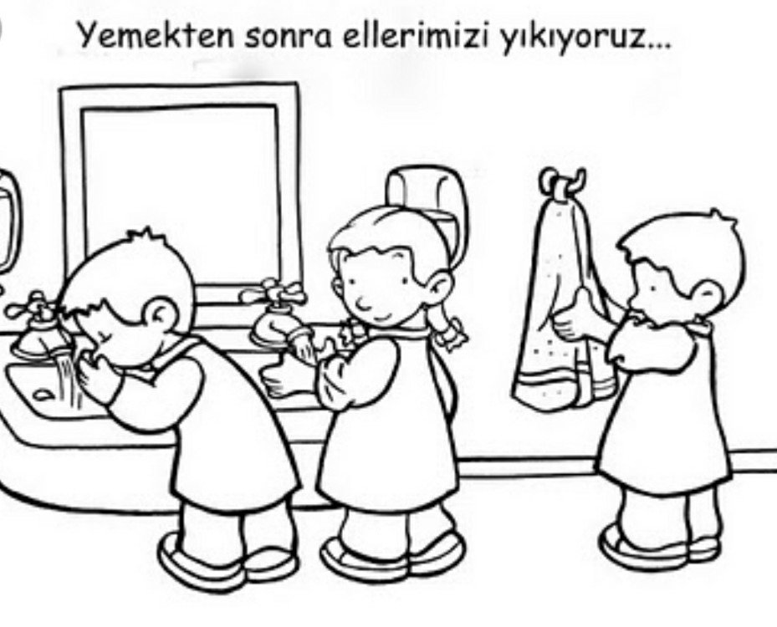](https://www.artibasari.com.tr/dokuman/3/2650)

[Ellerini yıka](https://www.artibasari.com.tr/dokuman/3/2650)

[](https://www.artibasari.com.tr/dokuman/3/2649)

[Özür dilerim](https://www.artibasari.com.tr/dokuman/3/2649)

[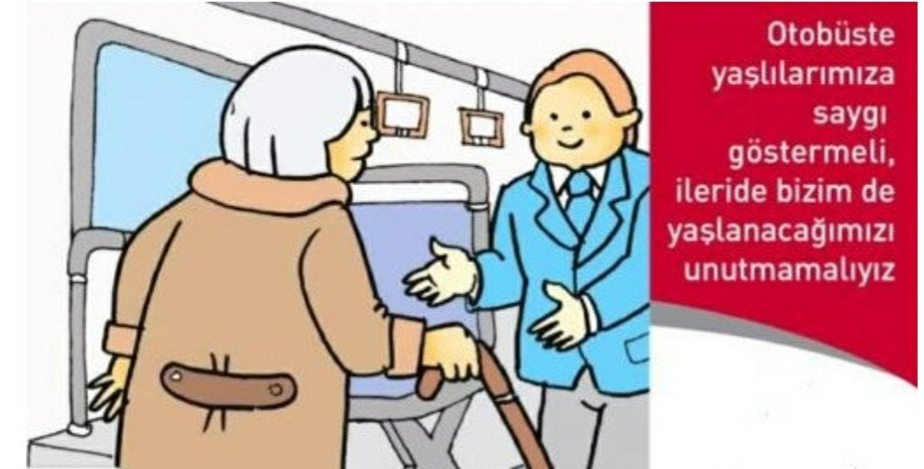](https://www.artibasari.com.tr/dokuman/3/2648)

[Yer ver](https://www.artibasari.com.tr/dokuman/3/2648)

[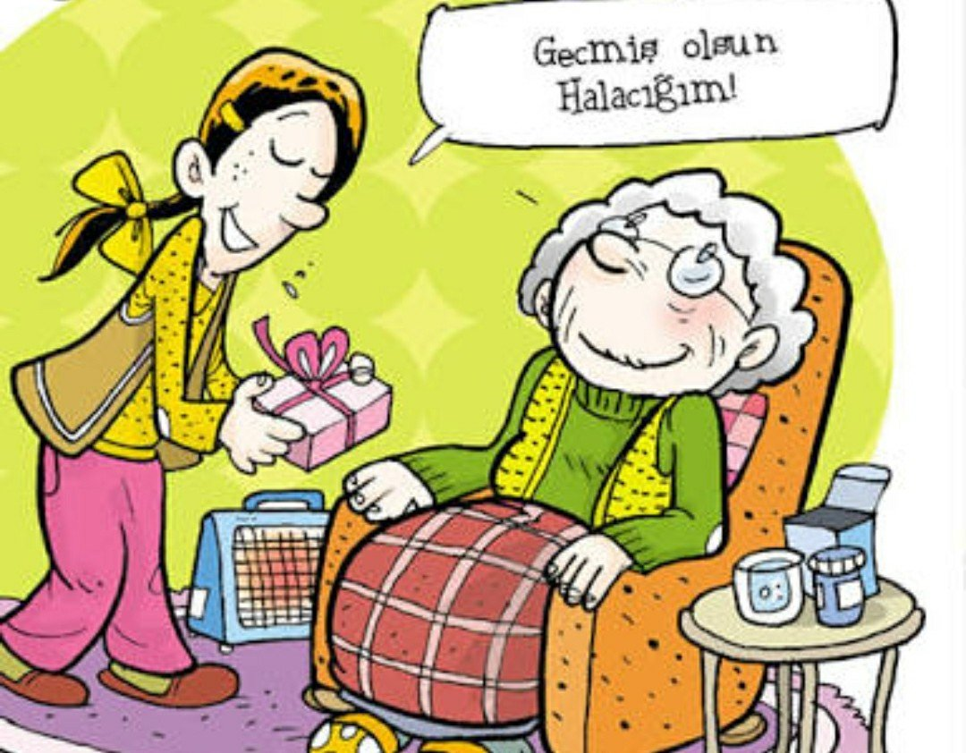](https://www.artibasari.com.tr/dokuman/3/2647)

[Geçmiş olsun](https://www.artibasari.com.tr/dokuman/3/2647)

[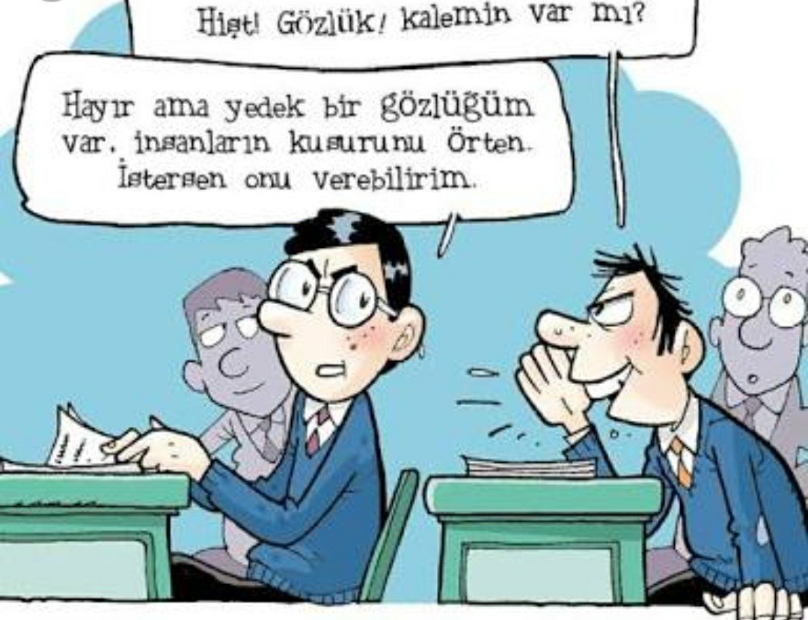](https://www.artibasari.com.tr/dokuman/3/2646)

[Lakap takma](https://www.artibasari.com.tr/dokuman/3/2646)

[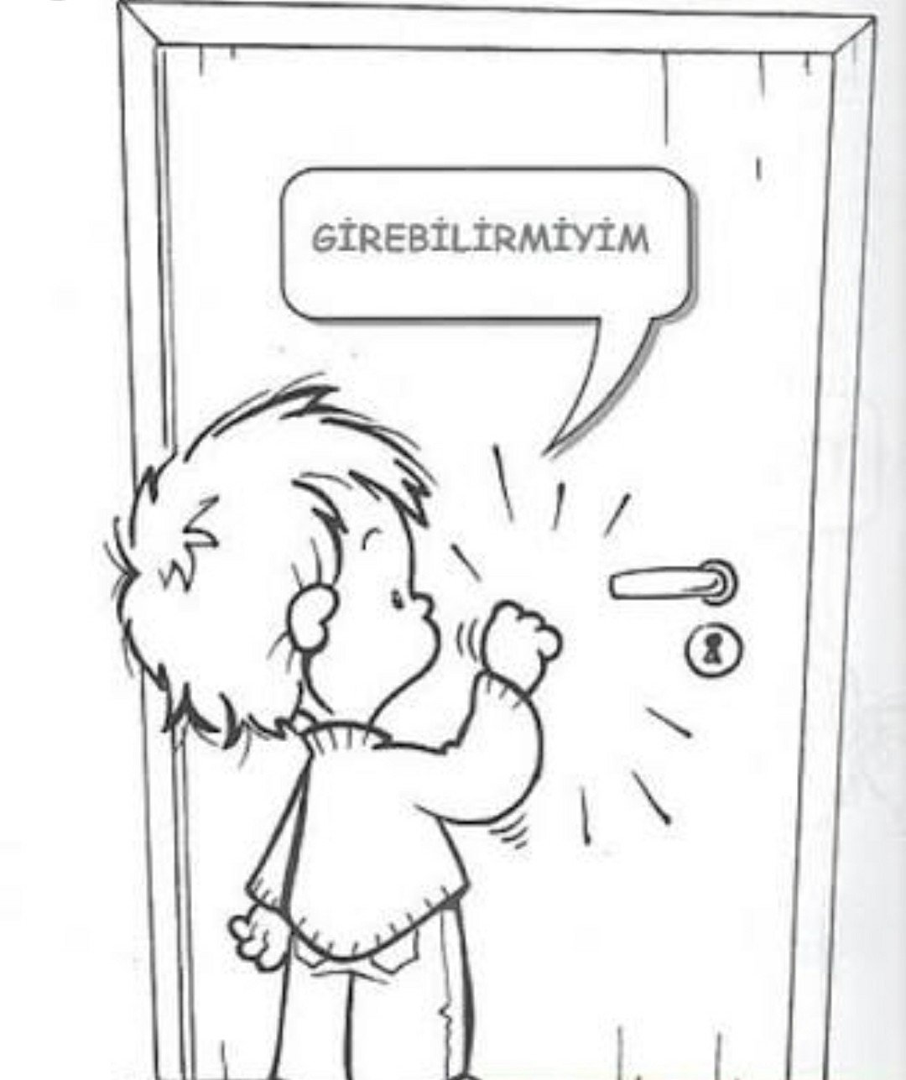](https://www.artibasari.com.tr/dokuman/3/2645)

[Girebilir miyim?](https://www.artibasari.com.tr/dokuman/3/2645)

[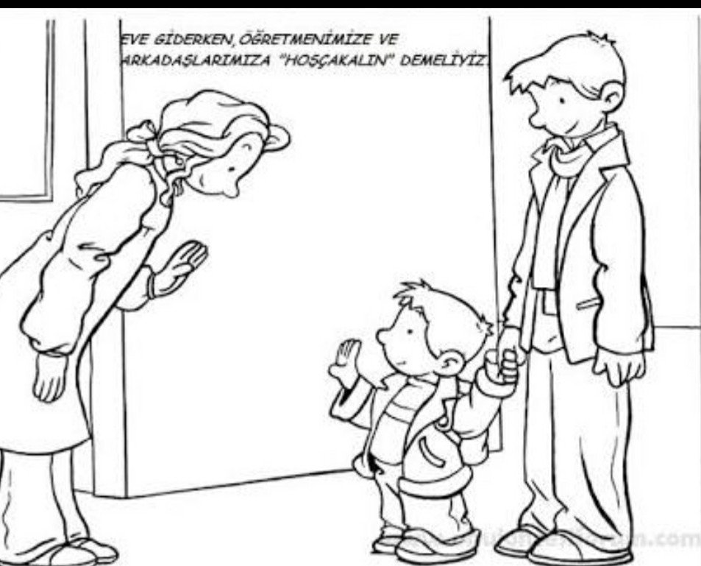](https://www.artibasari.com.tr/dokuman/3/2644)

[Hoşçakalın](https://www.artibasari.com.tr/dokuman/3/2644)

[](https://www.artibasari.com.tr/dokuman/3/2643)

[Parmak kaldır](https://www.artibasari.com.tr/dokuman/3/2643)

[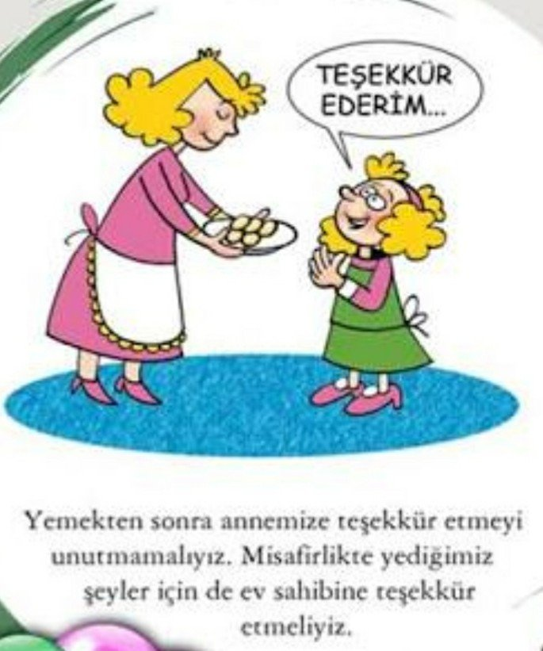](https://www.artibasari.com.tr/dokuman/3/2642)

[Teşekkür ederim](https://www.artibasari.com.tr/dokuman/3/2642)

[](https://www.artibasari.com.tr/dokuman/3/2641)

[Temizlik](https://www.artibasari.com.tr/dokuman/3/2641)

[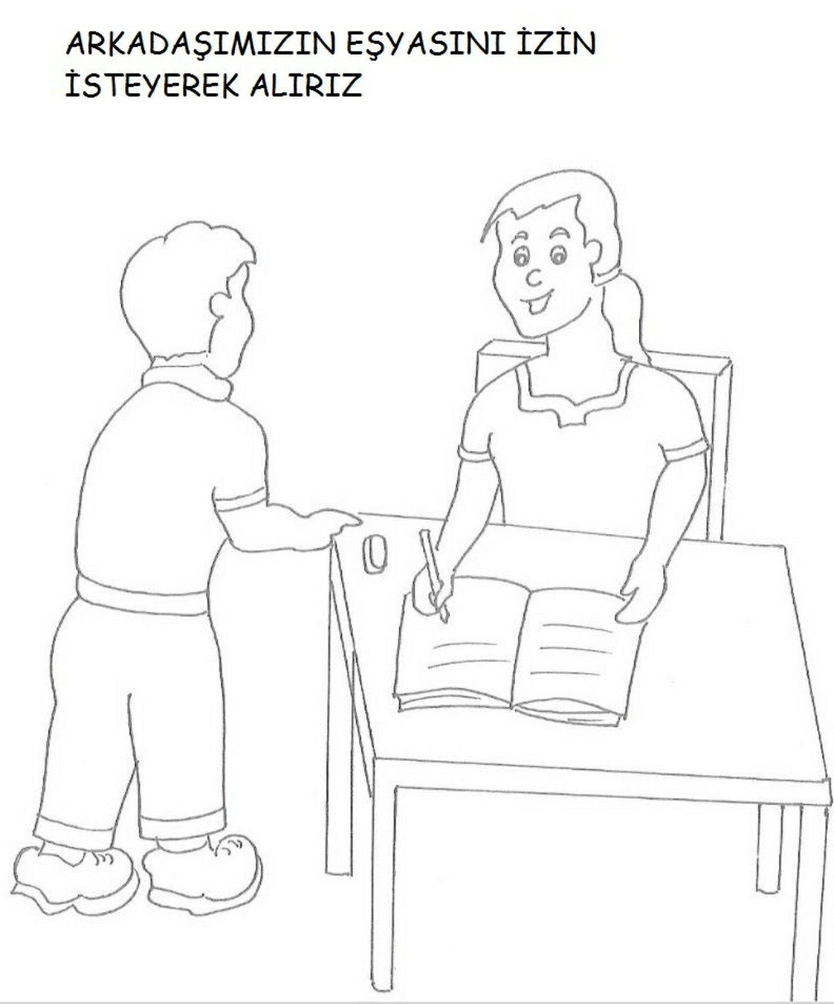](https://www.artibasari.com.tr/dokuman/3/2640)

[İzin iste](https://www.artibasari.com.tr/dokuman/3/2640)

[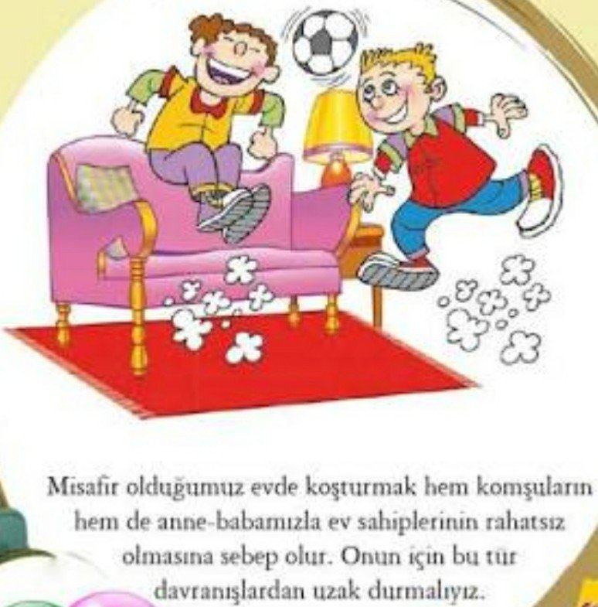](https://www.artibasari.com.tr/dokuman/3/2639)

[Misafir](https://www.artibasari.com.tr/dokuman/3/2639)

[](https://www.artibasari.com.tr/dokuman/3/2638)

[Bağırma](https://www.artibasari.com.tr/dokuman/3/2638)

[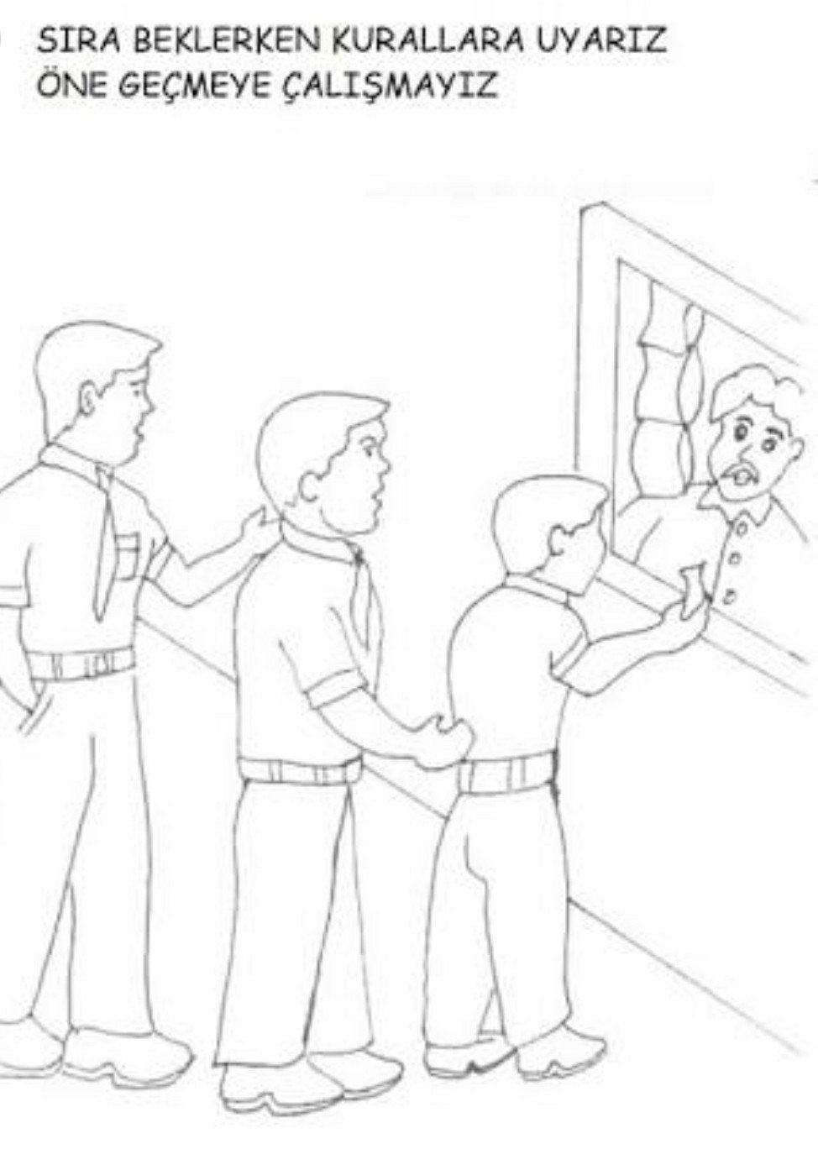](https://www.artibasari.com.tr/dokuman/3/2637)

[Sıra](https://www.artibasari.com.tr/dokuman/3/2637)

[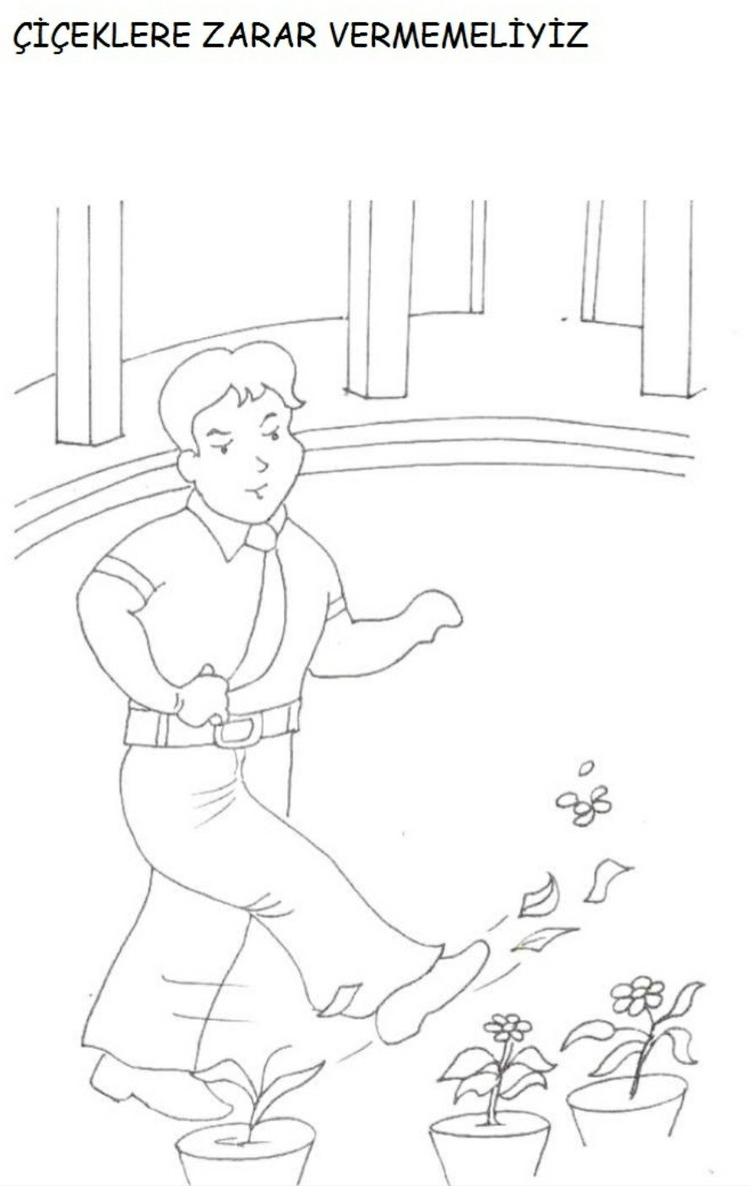](https://www.artibasari.com.tr/dokuman/3/2636)

[Çiçekler](https://www.artibasari.com.tr/dokuman/3/2636)

[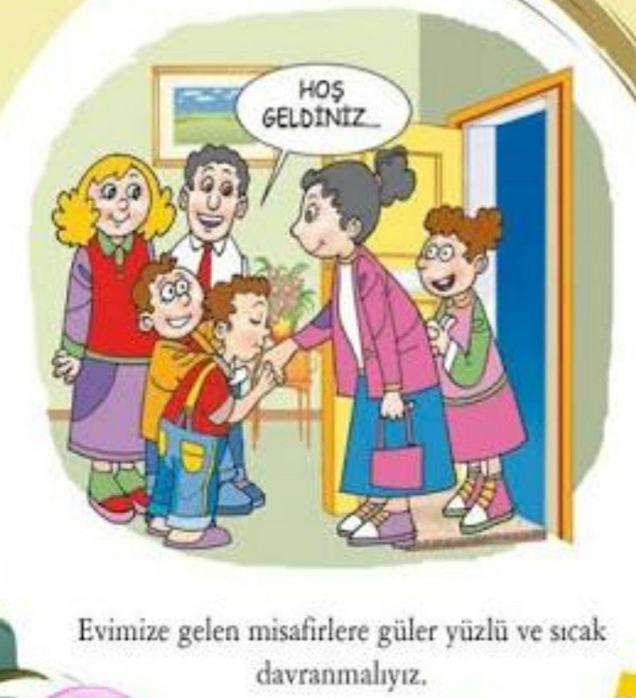](https://www.artibasari.com.tr/dokuman/3/2635)

[Hoş geldiniz](https://www.artibasari.com.tr/dokuman/3/2635)

[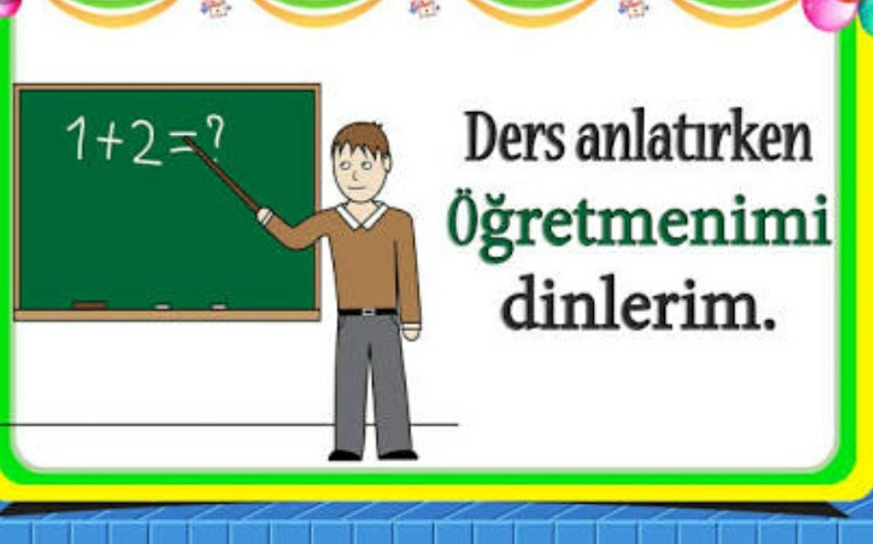](https://www.artibasari.com.tr/dokuman/3/2634)

[Öğretmenimi dinlerim](https://www.artibasari.com.tr/dokuman/3/2634)